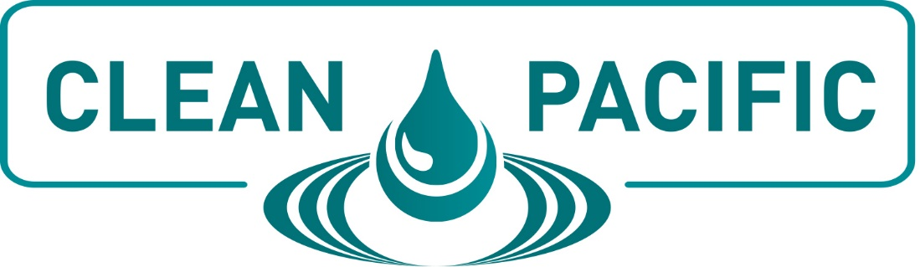

SAMPLE TRIP REPORT

Overview of Event:
The CLEAN PACIFIC 2019 conference was held at the Hyatt Regency Hotel in Vancouver, British Columbia. CLEAN PACIFIC addressed spill prevention and response matters pertinent to the Western United States and Canada’s environmental sensitivities.

The conference was structured into three days. The event featured workshops, breakout sessions and general sessions. There was a networking reception on Wednesday evening and networking breaks in the Exhibit Hall throughout the conference. All sessions were led by experts and offered ample time for questions at the end of each session.
The Exhibit Hall was held onsite during the conference. All networking breaks were in the Exhibit Hall, allowing for multiple opportunities to visit with companies and investigate new products and services.
All conference materials were included with my registration, as did the networking reception, networking lunches, and access to the Exhibit Hall.
Why Did I Choose To Attend?
CLEAN PACIFIC brings together operators, responders, regulators, equipment providers and environmental groups for three days of relationship building and sharing of best practices. The opportunity to learn from members in all facets of the spill response industry is invaluable.
The networking opportunities appealed to me, as did the opportunity to learn from some of the biggest stakeholders in the industry. I was particularly interested in sessions on <insert customized list here> since they directly relate to <insert aspects of your job or projects here>.
In addition to the conference sessions, the chance to network with other colleagues in similar situations was an extremely valuable experience. I was also able to interact with vendors in the Exhibit Hall at the CLEAN PACIFIC Conference. The opportunity to research new solutions and discuss current technologies with service experts was very worthwhile and cost-saving for my organization.
What Sessions Did I Find Most Valuable?
During the conference, I was able to attend numerous sessions. I was able to focus on topics that directly relate to my position at this facility/organization and find solutions for ongoing projects.
Sessions included:
<Insert Name, Speaker and Subject - List as many sessions as desired and included detailed descriptions of each one.>

Provide a listing of what you learned in the session and how it will apply to your organization.
What Networking Events Were Beneficial?
While at CLEAN PACIFIC, I was able to attend the welcome reception. It allowed me the first opportunity to visit with vendors, speakers and other attendees.
<List specific people, vendors or speakers you interacted with and the benefits of those discussions.>
Overall Summary of Conference Experience
I was very pleased with my conference attendance and felt it was well worth the registration fee and travel expenses. I learned new solutions and best practice strategies that can be implemented in our facility/organization. In addition, I gained valuable experience that couldn’t be obtained anywhere else. The networking experience was very beneficial. I was able to speak with several industry experts who provided tips and useful information for my particular dilemmas and work projects.
The conference was very organized and the speakers provided candid opinions on the subject matter at hand, making the information extremely valuable. The Exhibit Hall provided a friendly, informative place to meet with vendors and view their products and services.
In addition, the meals and refreshment breaks were extremely nice and allowed me to save on my travel budget. I was very pleased with all that I received at CLEAN PACIFIC.

